Life Cycle
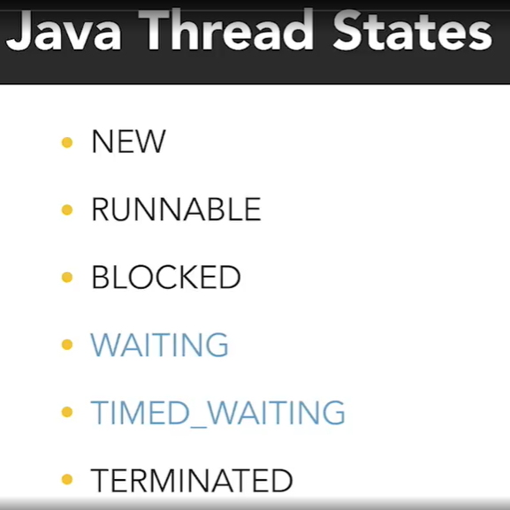
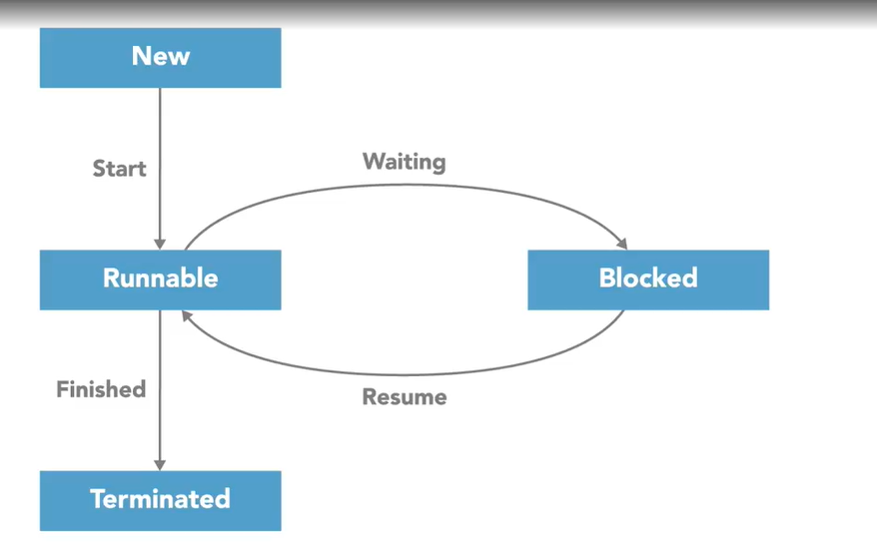
Method: join()
Wait until another thread completes its execution

Method:
Getting the Thread State
Thread.state getState()

Method:
Getting the Current Thread
Thread currentThread()

Thread ID
Positive, long number
Unique identifier for every thread
long getID()

Thread Name
String for identification
Multiple threads can have the same name
Default name structure Thread-N
void setName (String name)
String getName()

Thread Priority
1 = Lowest priority
10 = Highest priority
void setPriority (int newPriority)
int getPriority()

Threads do not maintain a reference to their parent thread

